**Chemistry 20 – Lesson 28**

**Acid/Base Stoichiometry**

**/77**

**Practice problems**

1. HCl(aq) + NaOH (aq)  NaCl (aq) + HOH (l)



2. The hydrochloric acid in a solution of kettle-scale remover is titrated with a 0.974 mol/L solution of sodium hydroxide. 10.00 mL samples of the acid solution were used. The color change of bromothymol blue indicator to green indicates the endpoint.

**Trial 1 2 3 4**

**Final burette reading (mL)** 15.6 29.3 43.0 14.8

**Initial burette reading (mL)** 0.6 15.6 29.3 1.2

**Volume of NaOH added (mL) 15.0 13.7 13.7 13.6**

**Color at endpoint** blue green green green

HCl(aq) + NaOH (aq)  NaCl (aq) + HOH (l)

We ignore trial 1 since the volume is substantially more than the other trials. In addition, the color at endpoint is blue rather than green.



**Assignment**

1.

/3 **The indicator should change at around pH = 7. Possible indicators are chorophenol red, bromothymol blue, phenol red, and phenolphthalein. In terms of indicating the exact equivalence point they would all work quite well since even a drop or two of acid or base in neutral water can change the pH by one or two points.**

2. HCl(aq) + NaOH (aq)  NaCl (aq) + HOH (l)



/6



3. 2 LiOH (aq) + HOOCCOOH (aq)  2 HOH(l) + LiOOCCOOLi (aq)



/4



4. HNO3 (aq) + NaOH (aq)  NaNO3 (aq) + HOH (l)



/6



5. H2SO4 (aq) + 2 RbOH (aq)  Rb2SO4 (aq) + 2 HOH (l)



/6



6. 2 CH3COOH(aq) + Ba(OH)2 (aq)  Ba(CH3COO)2 (aq) + 2 HOH (l)



/6



7. HBr (aq) + NaOH (aq)  NaBr (aq) + HOH (l)



/8



8.

**2 HA(aq) + Zn (s) → ZnA2 (aq) + H2 (g) (non–ionic)**

**2 H3O+(aq) + 2 A–(aq) + Zn (s) → Zn2+(aq) + 2 A–(aq) + H2 (g) + 2 H2O (l) (total ionic)**

**2 H3O+(aq) + Zn (s) → Zn2+(aq) + H2 (g) + 2 H2O (l) (net ionic)**



/10



9.

/2 **The following indicators change colour at 4.4 (approximately): methyl orange, bromocresol green, methyl red.**

10.

**Trial 1 2 3 4**

**Final burette reading (mL)** 17.9 35.0 22.9 40.1

**Initial burette reading (mL)** 0.3 17.9 5.9 22.9

**Volume of HCl(aq) added (mL) 17.6 17.1 17.0 17.2**

**Color at endpoint** red orange orange orange

Na2CO3 (aq) + 2 HCl(aq)  H2CO3 (aq) + 2 NaCl (aq)



We ignore trial 1 since the volume is substantially more than the other trials. In addition, the color at endpoint is red rather than orange.

/6



11. NH3 (aq) + HCl(aq)  NH4Cl (aq)



We ignore trial 1 since the volume is substantially more than the other trials. In addition, the color at endpoint is yellow rather than green.

/6



12.

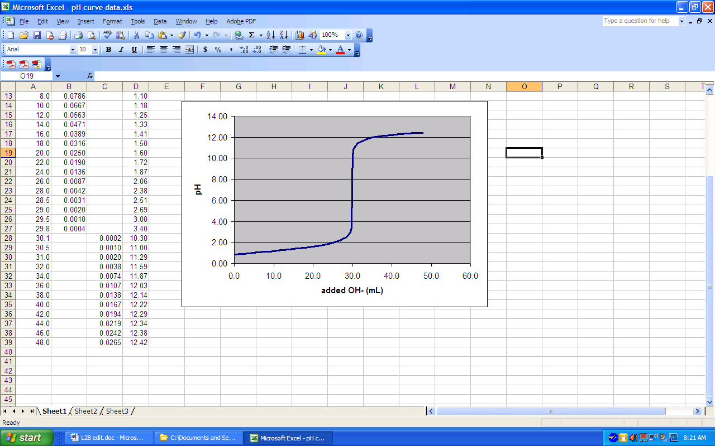

equivalence point

/10

HCl(aq) + NaOH (aq)  NaCl (aq) + HOH (l)



13.

/4

|  |  |  |  |
| --- | --- | --- | --- |
| curve | volume of titrant | pH | indicator(s) |
| a | 20 mL | 7 | bromothymol blue, phenolphthalein |
| b | 20 mL | 9 | phenolphthalein, thymolphthalein |
| c | 20 mL | 5 | bromocresol green, methyl red |
| d | 20 mL | 7 | bromothymol blue, phenolphthalein |